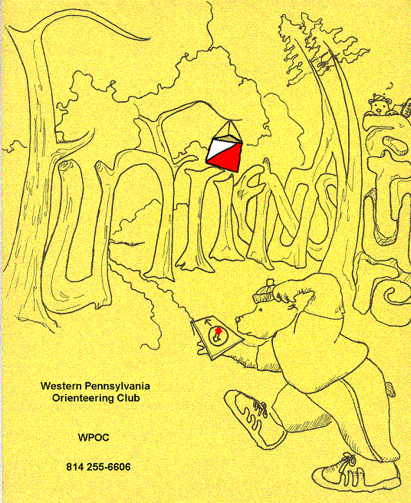
Jim Wolfe – President – (814) 255-6606 (nights)
(724) 357-6104 (days)
jlwolfe@atlanticbb.net
Bryon Roland – Vice-President – (724) 357-9328
bman66@adelphia.net
Jennifer Livingston – Secretary – (724) 770-1120
jenlivi@pobox.com

WPOC scores big at Michaux Memorial Day Rogaine
WPOC had strong showing at the Michaux Memorial Day Rogaine hosted by the Susquehanna Valley Orienteering club on May 27, 2006. Jim Wolfe competed as a solo in the 6-hour event and scored a very respectable 321 points, which was good enough for 9th place overall and with just one more control he would have placed 5th overall. It has been six years since Jim had competed in a rogaine. He is getting some practice in for several orienteering events he will be attending in July. Jim thought that the event was challenging because, “there wasn’t much water on the course and because there were lots of areas of stony ground.”
Barbara Johnstone and friend competed in the 6-hour event and placed second in the female division. It was the first time Barbara and Deb had competed in a rogaine and Barbara compares it to a score course at a orienteering meet where you need to find “as many controls as you can in a pre-set span of time.” But, she notes, “ the scale of the event was different in every way: the distance between controls could be miles, the competition could last 24 hours, and the maps were regular topo maps, not the finely detailed maps that are so helpful at orienteering meets.” She notes, “We did what we hoped to do. We found a couple of controls. We didn’t get lost -- a feat that required all of our combined map and compass skills and our level-headedness. We had a nice seven- or eight-mile walk in the woods, where we saw some stunning lady’s slippers in full bloom. And much to our surprise, we ended up in second, not third, place! We’re probably not going to be signing up for the 24-hour event next year, but we’ll be trying this again. It was a friendly crowd, a lovely site, and a rewarding day.”

Bryon Roland and Mary McElhinny competed in the 12-hour coed division and placed second in the coed division and third overall. Bryon commented that the points were “dead on” and the navigation was challenging due to the older topo maps used and many road and trails were not on the map, in fact the Appalachian Trail was not even completely marked on the maps and a section of fenced in private property made the location of one point extremely difficult to locate. There were only 2 water stops on the course, which made the planning of our routes very tricky due to the very warm temperatures and need to rehydrate. There were 42 possible controls and each control had a different value assigned to it and the higher the number the more challenging the terrain and/or orienteering with the total possible point value of 1710. The event was well attended and well supported. We did think that the unique stained glass orienteering marker awards made all the hard work worthwhile!

Venture Outdoors Festival
WPOC members John Hartman, Alexis Rzewski and Barbara Johnstone manned a booth at the Venture Outdoors Festival on May 20, 2006. The Venture Outdoors Festival, sponsored by UPMC Health Plan is a free event where individuals and families can sample the many outdoor activities available in our region. The following is a report from Alexis, “a very nice day, with canoers on the river, climbers on climbing walls, and stragglers weaving around and mingling with other outdoor enthusiasts, the WPOC booth was smartly located near one of the entry points next to a children's activity booth, and capturing a lot of attention at those first walking into the main thoroughfare. The big map in color flat on the table was a big eye-catcher, and people stopped and inquired. One of them was a cartographer working for CMU. Others were girl scouts leaders. But many were folks that never heard of this sport activity.” It is always great to get the word out about what a great sport orienteering is and hopefully a few of the people that stopped by the booth will come out and try a WPOC event.
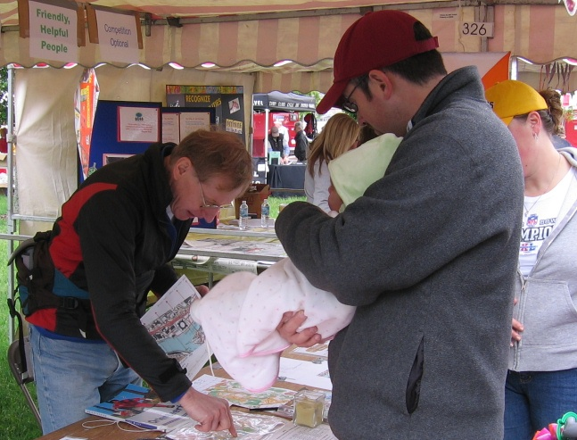

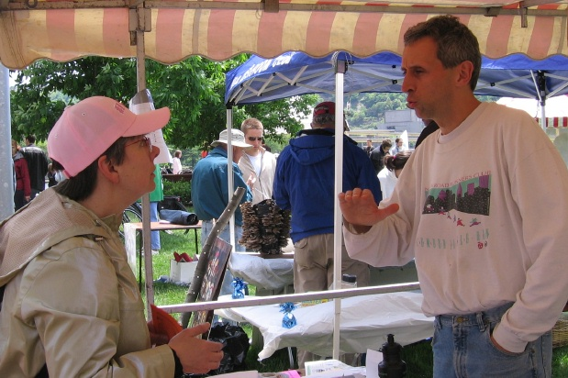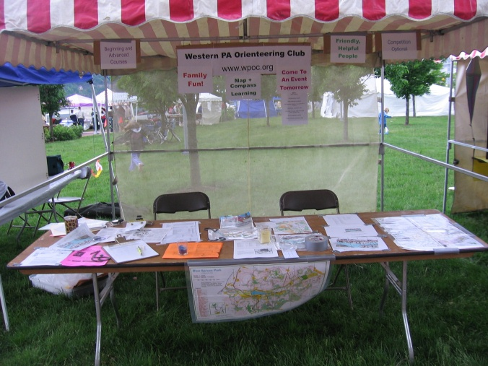
John, Barbara and Alexis at the WPOC Booth at the Venture Festival!

WPOC and Grassroots Adventure Racing
WPOC was contacted earlier this year to help set up the orienteering portions of some local adventure races with a new race company called Grass Roots Adventure Racing. Bryon Roland set up an O-course for the Yellow Creek Creeper Adventure Race at Yellow Creek State Park on June 3, 2006 using the club map for which the club was reimbursed. For those not familiar with adventure racing, it is usually a team event can include paddling, biking, rope work, running and orienteering and a race can range from several hours to 10 days. Map reading skills are essential for adventure racing therefore a good O-course is very beneficial. The participants overwhelming loved the O-course set up and run by Bryon. Four of the adventure racers even came out to the Blue Spruce Event to get more orienteering experience. If you want to learn more about the events sponsored by Grass Roots Racing visit their website at http://www.rootsrace.com/
Permanent O-course at Stackhouse
By the end of July, there should be a permanent orienteering course in Stackhouse Park, Johnstown. The purpose of such a course is to provide a practice facility for orienteering and to provide a place for anyone to orienteer during times when no meets are available. The course is being created under the direction of Adrienne Oldham for her Gold Award Project. She is lining up people to dig holds and plant posts. The markers have already been acquired and their locations have been chosen.
Jim Wolfe has selected twenty control points. These will be marked with 4” x 4” orange and white plastic markers on metal poles cemented into the ground. Maps showing the locations of the markers will be available at the park ranger station (they will be free). The maps have the control descriptions printed on them and suggestions for three different courses, which start and finish at the ranger station. However, the twenty controls can be used like a Score course; thus, anyone may use one of the maps to practice on any subset of the controls. Also, once a person has a map, s/he does not have to start at the ranger station; there are two other park entrances with parking lots so the person can start at either of these places and choose a completely different control sequence.
As soon as the permanent course is ready to go, you will see a link to the O-course on the website, www.wpoc.org. In addition, there will probably be an announcement through the usual e-mail channel. This will be one of the few permanent orienteering courses in all of western Pennsylvania.
Note: If you follow the driving directions to Stackhouse Park given on the WPOC web page (Maps & Directions link), you will enter Stackhouse Park right next to the ranger station.

?? Question of the Newsletter – What is a catching feature?

Event recaps:
University Farm Meet -The third meet of the year was held at the University Farm on May 21, 2006 and Jim Wolfe was the meet director. The weather did not cooperate early on it was cold, windy and rainy; this contributed to a low turnout but everyone was treated to excellent courses. The club added one new member, Matt Miklasevich. Welcome Matt! Thanks to John Hartman, Barbara Johnstone, and Laurie Opila for covering registration. Also, thanks to Jennifer Livingston and Jason Gray for brief assistance at the start/finish. Finally, thanks to Johns Hartman and Jason Gray for helping to pick up the controls. Here are the results:
White Course 2.58 km 70 m climb 9 controls
Matt Miklasevich | WPOC | 65:21
Jennifer Livingston clan | WPOC | 65:47
Tyler Richter & Ryan Snyder | BSA - Troop 58 | 97:08
Yellow Course 3.22 km 175 m climb 11 controls
Jason McKenna |  | 58:40
Wayne Richter | WPOC | 77:26
Tom Kaveney & Heidi Adams - missed two controls, 123:50 |  | DNF
Orange Course 4.48 km 190 m climb 11 controls
Jason Gray | WPOC | 83:26
Mark & Chris Malagodi |  | 101:33
Laurie Opila | WPOC | 148:00
Barbara Johnstone | WPOC | 188:12
Green Course 5.12 km 225 m climb 13 controls
John Durrant | DVOA | 88:40
Jason Gray | WPOC | 91:24
John Hartman | WPOC | 91:36
James Trautmann |  | 104:12
Phil Martineau - found only 7 controls 98:40 | WPOC | DNF

Blue Spruce Meet Recap – The fourth meet of the spring took place on June 17, 2006 at Blue Spruce State Park. It was sunny, hot, humid day; the temperature was close to 90º, a real contrast to the previous meet. We had a moderate turnout, certainly better than in May but nothing to rival our best turnout. Bryon Roland was meet director and set some interesting and challenging courses; most of the participants successfully navigated them but with relatively slow times. We had one new member join; welcome to Mark Malagodi. Thanks to Laurie Opila, Al Sheaffer, Wayne Richter, and Tammy Cash for running registration. Thanks to Mary McElhinny and Alexis Rzewski for running start and finish. And thanks to John Hartman, Mary McElhinny, and Alexis Rzewski for taking down the controls. The next event will be in September for National Orienteering Day. Here are the results from the Blue Spruce Event:
White Course 2.0 km 70 m climb 9 controls
Hillie Billie | Cub Scouts Pack 145 | 57:11
Sean Cousins | BSA - Troop 670 | 59:35
Cody Henry | BSA | 60:48
Keri Lawless |  | 66:43
The Rednecks | BSA - Troop 50 | 69:13
Austin Davis | BSA - Troop 670 | 71:32
Janet, Chris & Carl Malagodi |  | 77:58
Kevin D & Jenny S |  | 79:00
Yellow Course 3.3 km 130 m climb 9 controls
Lenny Lewis, Zach Anderson & Bobby | Venture Crew | 31:25
Piper Family | WPOC | 43:56
Sandy & Tanya |  | 91:42
Karen Gracy | WPOC | 101:14
Smores |  | 115:02
Kevin Doty |  | 125:52
Orange Course 4.5 km 160 m climb 12 controls
Mark Malagodi | WPOC | 96:58
Mike Houck & Mary Ann Hanlon |  | 108:20
Laurie Opila | WPOC | 154:54
Keith & Frances Irvin | WPOC | 207:28
Al Sheaffer - missed #8, 131:52 | WPOC | DSQ
Wayne Richter - stopped after 7 controls, 101:53 | WPOC | DNF
Green Course 5.7 km 295 m climb 13 controls
Alexis Rzewski | WPOC | 97:02
James Trautmann |  | 101:22
John Hartman | WPOC | 104:17
Mary McElhinny | WPOC | 147:58

Complete meet results starting in 2003 can be viewed on line at wpoc.org.

Answer: A catching feature (also called a Collecting Feature or Backstop) lets you know if you’ve gone to far. It is usually a large distinct feature that you can’t fail to recognize which indicates that the target feature has been over-shot.

Fall WPOC Events:
- September 16, 2006- Saturday- Boyce Park, Plum Borough– Meet director, Jerry Agin - National Orienteering Day Event – 11:00 am to 2:00 pm – White, Yellow, Orange and Green
- October 1, 2006 – Sunday- Stackhouse Park, Johnstown – Meet director, Jim Wolfe - 11:00 am to 2:00 pm – White, Yellow, Orange and Green.
- October 14, 2006 – Saturday- Camp Seph Mack, Night Course-mass start at 7:45 pm – Meet director, Bryon Roland
- November 15, 2006 – Sunday- Pine Ridge Park, Blairsville – 11:00 am to 2:00 pm – Directed by John Hartman and Jim Wolfe - White, Yellow, Score – Meet Director, Jim Wolfe –
Directions: Directions: Please check the WPOC website since the directions for all meets are posted on the web site and they are very detailed.

For those WPOC members that love to orienteering and travel, listed below are some nearby Club addresses for when you looking want to have a fun weekend:
- QOC - Quantico Orienteering Club serving Virginia, Maryland and District of Columbia. http://qoc.us.orienteering.org/
- ROC - Rochester Orienteering Club – New York http://roc.us.orienteering.org
- DVOA – The Delaware Valley Orienteering Association – www.dvoa.us.orienteering.org
- NEOCC- North Eastern Ohio Orienteering Club – http://neooc.home.att.net/.
- SVO – Susquehanna Valley Orienteering, Near York, PA –
http://d-domains.net/svo/

WE are always looking for new members; therefore you will find a membership application on the last page of the newsletter. If interested! You can also download the application on the wpoc website.

Application for Membership in the
Western Pennsylvania Orienteering Club
I hereby apply for membership in the WPOC. I understand that membership entitles me to a discount in membership dues in the United States Orienteering Federation; I also understand that WPOC dues support the club's activities of putting on orienteering events in Western Pennsylvania.
PLEASE PRINT
Name __________________________________ Phone ___________________
Address ________________________________ E-mail ___________________
_________________________________
Individual dues are $10. Membership expires annually in January. Send this form with a check made payable to WPOC to
WPOC
c/o James L. Wolfe,
1904 Bates Drive
Johnstown, PA 15905

